caTissue MAGE-TAB Integration Design

Authors | Carlos E. Perez and Denis Krylov
Reviewers | Patrick McConnell
Architecture Inception Team
Document Change History
Version Number | Date | Contributor | Description
0.0.1 | 08/26/2010 | Carlos Perez | Initial version
0.0.2 | 10/25/2010 | Carlos Perez | Updated based on discussions with Rakesh, Mark, caArray
0.0.3 | 11/29/2010 | Carlos Perez | Update to include export UI
0.0.4 | 12/2/2010 | Carlos Perez | Clean up and more text
0.0.5 | 12/7/2010 | Carlos Perez | Update using mapping files and system flow.
0.0.6 | 12/9/2010 | Carlos Perez | Updated based on review by Patrick McConnell
0.0.7 | 12/16/2010 | Carlos Perez | Updated to reflect comments by Rahsmi Srinivasa, Srikanth Adiga, Poornmima Govindrao
0.0.8 | 12/22/2010 | Carlos Perez | Formatting update by Jithu Ramesh
0.0.9 | 01/27/2011 | Carlos Perez | Updated to reflect Poornima comments
0.0.10 | 2/16/2011 | Carlos Perez | Updated with Alexander comments
0.0.11 | 02/16/2011 | Carlos Perez | Updated by Jithu Ramesh
0.1 | 03/03/2011 | Denis Krylov | Updated mapping tables: IDF-to-caTissue, SDRF-to-caTissue, MGED Material.
0.1 | 03/07/2011 | Denis Krylov | Formatting update by Jithu Ramesh

Table of Contents
1 MAGE-TAB Integration 4
1.1 Scope 4
1.2 Out of Scope 4
2 Use Cases 5
2.1 MAGE-TAB Specimen Export 5
3 Algorithm for Selecting Source, Sample and Extract 5
4 MAGE-TAB Export UI 6
4.1 MAGE TAB Specimen Export UI 6
5 MAGE-TAB to caTissue Mapping 10
5.1 MAGE-TAB (v1.0) File Description 10
5.2 caTissue Object Model 12
5.3 IDF caTissue Mapping 13
5.4 SDRF caTissue Mapping 16
5.4.1 MGED Material Type to caTissue Mapping 19
6 Implementation 20
6.1 System Flow 22
7 References 24

MAGE-TAB Integration
The sharing of microarray data within the research community is facilitated by the use of a common data format. MAGE-TAB is a simple, tab delimited spreadsheet-based format that is a part of the MAGE microarray data standard. It is used for annotating and communicating microarray data. The purpose of this document is to address the requirements for integrating MAGE-TAB exchange capabilities with the caTissue software product.

Scope
MAGE-TAB is a tab delimited format that serves as an alternative format to the more complicated MAGE-ML format that is based on XML. MAGE-TAB is a categorization of different formats:
- Investigation Design Format (IDF)
- Array Design Format (ADF)
- Sample and Data Relationship Format (SDRF)
- Data Files
The scope of this project is to allow users to export MAGE-TAB formatted files using information derived from specimen data stored in caTissue. The MAGE-TAB files include information such as specimen global identifiers, material type, pathology/clinical status, and associated annotations such as tumor grade and stage.
caTissue users can use the Query Results page to select specimens to be included in an exported MAGE-TAB formatted file.

Out of Scope
The following identified requirements are out of scope for this project:
- Integration of caTissue and caArray data sets using shared common data elements.
- Pushing identifiers and annotations of interest from caTissue into an existing or a new caArray experiment (as opposed to the proposed ‘pull’ only approach).
- The ability to navigate directly from caArray to caTissue to view detailed information about a sample that has been profiled and whose data has been stored in caArray.
- Importing MAGE-TAB formatted files into caTissue.

Use Cases

MAGE-TAB Specimen Export
Brief Description | Select a specimen and export MAGE-TAB that includes specimen identifiers and selected annotations (specifically, Sample and Data Relationship Format (SDRF)) and the Investigative Design Format (IDF). The SDRF file will include caTissue data such as specimen global identifier/label/barcode, material type, pathology/clinical status, and associated annotations.
Primary Actor(s) | Investigator: A PI who owns the experiment under discussion or a scientist who enters data on the PI’s behalf.
Secondary Actor(s)
Preconditions | The investigator has logged into the caTissue system. A Specimen exists within the system and is selected by the user.
Basic Flow of Events | - Investigator obtains a list of specimens via Search screens, My List screen, or via Relocation Event. Alternatively, Investigator may pick a specimen distribution for export.  - Investigator picks specimens to export or marks an entire distribution for export.  - Investigator chooses whether the extracts are RNA or DNA, if extract’s type cannot be determined automatically.  - Investigator selects the source and samples for the selected specimens.  - Investigator selects attributes of the annotations of interest that he/she wants to export.  - Investigator exports the specimens (with unique IDs and selected annotations) into MAGE-TAB v1.0 set of files.
Post Conditions | A MAGE-TAB formatted set of files is exported for the selected user. Details of the mapping of caTissue domain model are located in the mapping section of this document.
Alternate Flow | None.
Special Requirements | None.

MAGE-TAB Specimen Distribution Export

Algorithm for Selecting Source, Sample and Extract
Identify specimen type T (i.e. non-DNA or non-RNA)
If (selection is a non-molecular specimen) then,
Source <- selection
Sample <- selection
Extract <- pick-child-specimen (selection, T)

Function pick-child-specimen (selection, T)
Result <- gets most immediate child of type T in the distribution
For two or more children,
Result <- specimen that is available and quantity > 0 that is in the distribution.

If (selection is a molecular specimen) then,
Source <- Top most specimen in selection’s parent hierarchy
Sample <- Top most specimen in selection's parent hierarchy if no children are in between, else derivative non-molecular specimen that is next top most in the hierarchy under the source.

Note: The likelihood is that a majority of the annotations are on the top.

MAGE-TAB Export UI

MAGE TAB Specimen Export UI
MAGE-TAB export is accessible from the “MyList” view. Clicking on the MAGE-TAB Export button triggers the export wizard.
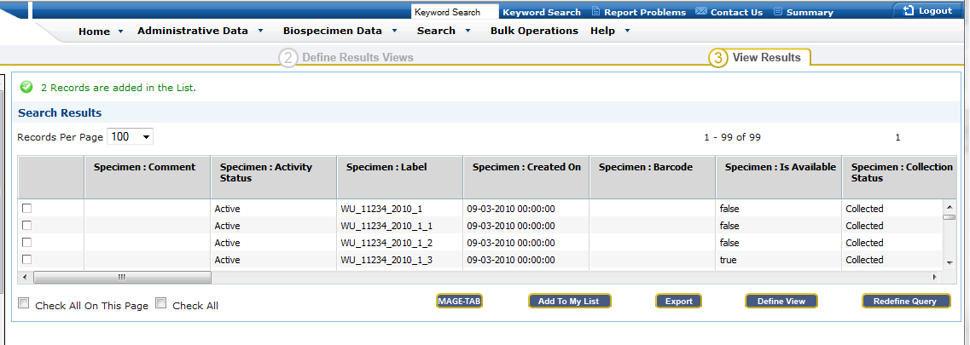

Or alternatively in the My List View:
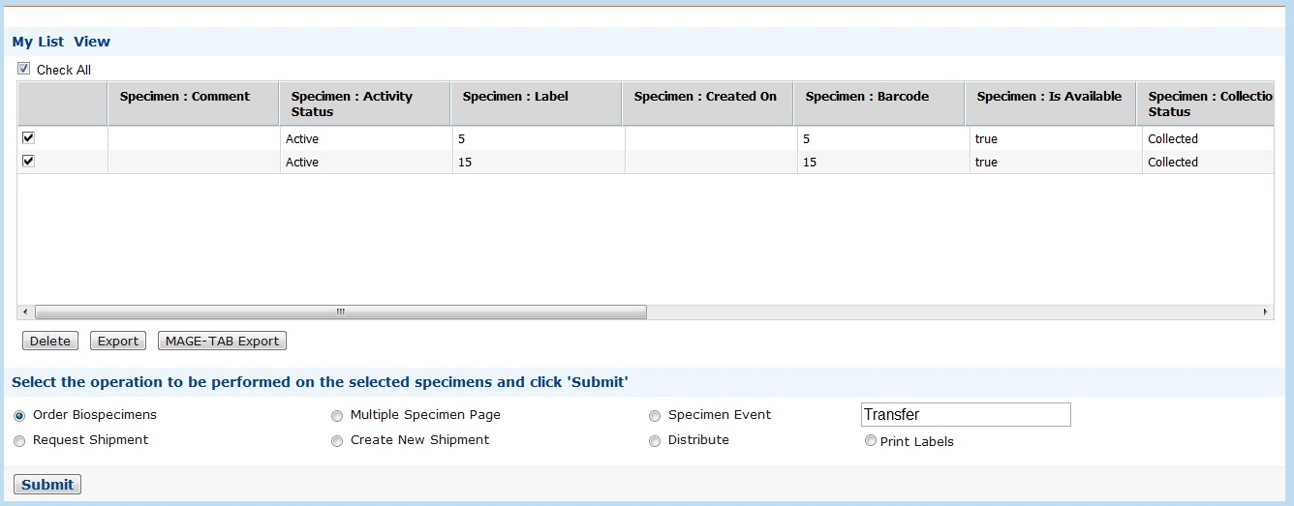
When the user clicks on the “MAGE-TAB Export” button, the UI will ask the user if all the specimens are DNA- or RNA-export:
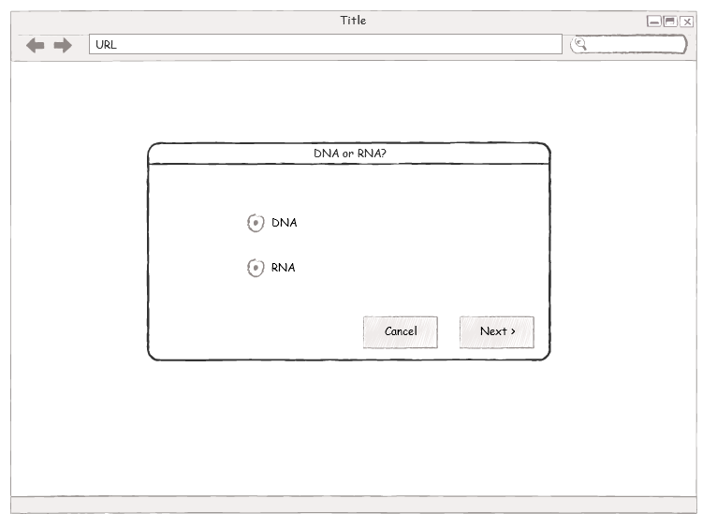
This dialog will not appear if all the specimens are already listed in one of the sets.
On selection, a spreadsheet will be shown for each of the selected specimens. Dropdowns will be provided for the user to select the source and samples. The dropdowns will be dynamic, if a source is selected; only the valid samples (i.e. specimens that are children of the source) will appear in the dropdown menu.
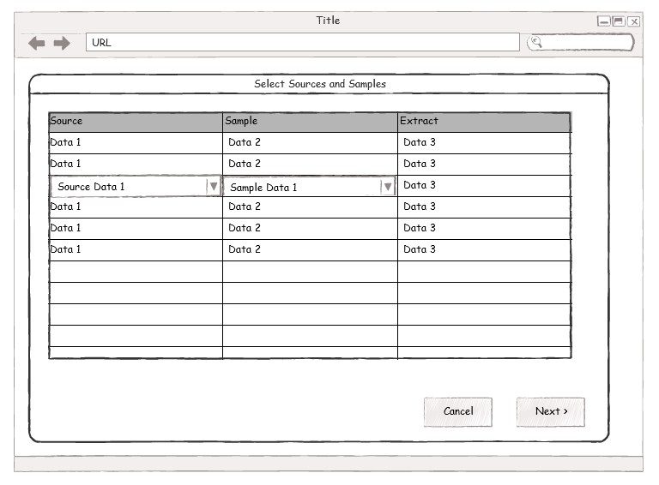
On selecting the ‘Next’ button, the following view will be shown:
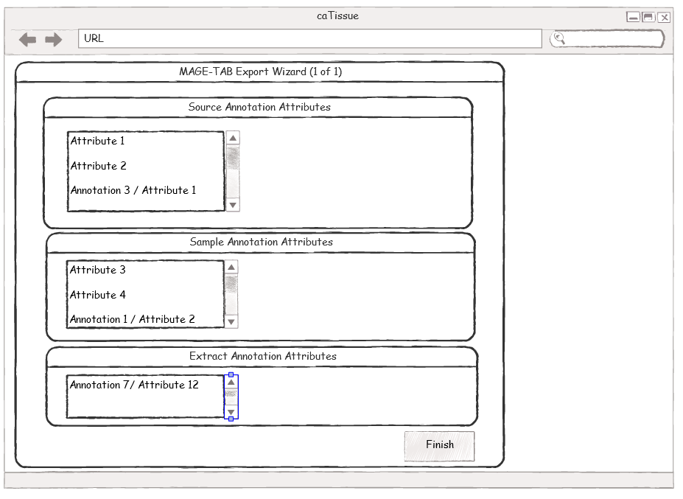
Annotations from the static model will be shown. These are specifically:
Participant:
- Race
- Ethnicity
- Gender
- Date of birth
  - Age is a calculated value that will go into MAGE-TAB export file
Specimen Collection Group:
- Clinical diagnosis
- Clinical status
- Study calendar event point
Specimen:
- Specimen type
- Tissue site
- Pathological status

This view allows the user to select the annotations to appear in the MAGE-TAB file. Clicking the “Back” button moves the user to the previous wizard screen.

MAGE-TAB to caTissue Mapping

MAGE-TAB (v1.0) File Description
A short description of the Investigative Design Format (IDF) can be found here: http://tab2mage.sourceforge.net/docs/idf.html. The IDF format includes meta-data about the experimental design, persons and their roles in the experiment, term sources, quality, protocol, and publication. Finally, references to other MAGE-TAB files are included. An example for this file is provided below:
Investigation Title | Invasive vs. non-invasive strains of yeast
Experimental Design | individual_genetic_characteristics_design | growth_condition_design
Experimental Factor Name | EF_Genotype | EF_GrowthCond
Experimental Factor Type | Genotype | growth_condition
Person Last Name | Falstaff | Shakespeare
Person First Name | John | Bill
Person Email | jfalstaff@wagglespike.com | bills@wagglespike.com
Person Address | Ontario, Canada | Ontario, Canada
Person Affiliation | Windsor Laboratories | Windsor Laboratories
Person Roles | submitter;investigator | investigator
Quality Control Type | dye_swap_quality_control
Public Release Date | 2004-08-30
PubMed ID | 12345678 | 87654321
Publication Author List | Falstaff, J. and Shakespeare, B. | Goodfellow, R. et al.
Publication Title | Improved yeast flocculation | Yeast and beer: a retrospective
Publication Status | in preparation | submitted
Experiment Description | An experiment was performed to...
Protocol Name | Yeast Growth | RNA extraction
Protocol Type | Grow | nucleic_acid_extraction
Protocol Description | S. cerevisiae cultures were grown on... | Total cellular RNA was extracted...
Protocol Parameters | carbon source;temperature
SDRF File | my_sdrf_file.txt
The Sample and Data Relationship Format (SDRF) http://tab2mage.sourceforge.net/docs/sdrf.html file consists of a table where each step of the experiment in the hybridization channel is represented by rows and columns. Also, it should be read left-to-right in chronological order.
Example:
Source Name | Characteristics [OrganismPart] | Labeled Extract Name | Label | Protocol REF | Hybridization Name | Array Design REF
liver sample 1 | liver | LE 1 | biotin | Hyb protocol name | Hyb 1 | A-AFFY-33
liver sample 2 | liver | LE 2 | biotin | Hyb protocol name | Hyb 2 | A-AFFY-33
kidney sample 1 | kidney | LE 3 | biotin | Hyb protocol name | Hyb 3 | A-AFFY-33
kidney sample 2 | kidney | LE 4 | biotin | Hyb protocol name | Hyb 4 | A-AFFY-33

Hybridization Name | Array Design REF | Scan Name | Array Data File | Protocol REF | Normalization Name | Derived Array Data File | Factor Value [FactorOP]
Hyb 1 | A-AFFY-33 | Scan 1 | Data1.CEL | Norm protocol name | Norm 1 | Data1.CHP | liver
Hyb 2 | A-AFFY-33 | Scan 2 | Data2.CEL | Norm protocol name | Norm 2 | Data2.CHP | liver
Hyb 3 | A-AFFY-33 | Scan 3 | Data3.CEL | Norm protocol name | Norm 3 | Data3.CHP | kidney
Hyb 4 | A-AFFY-33 | Scan 4 | Data4.CEL | Norm protocol name | Norm 4 | Data4.CHP | kidney

caTissue Object Model
The caTissue domain model includes a Specimen class that is derived from an AbstractSpecimen class. The AbstractSpecimen class includes the relationship between a parent and child.
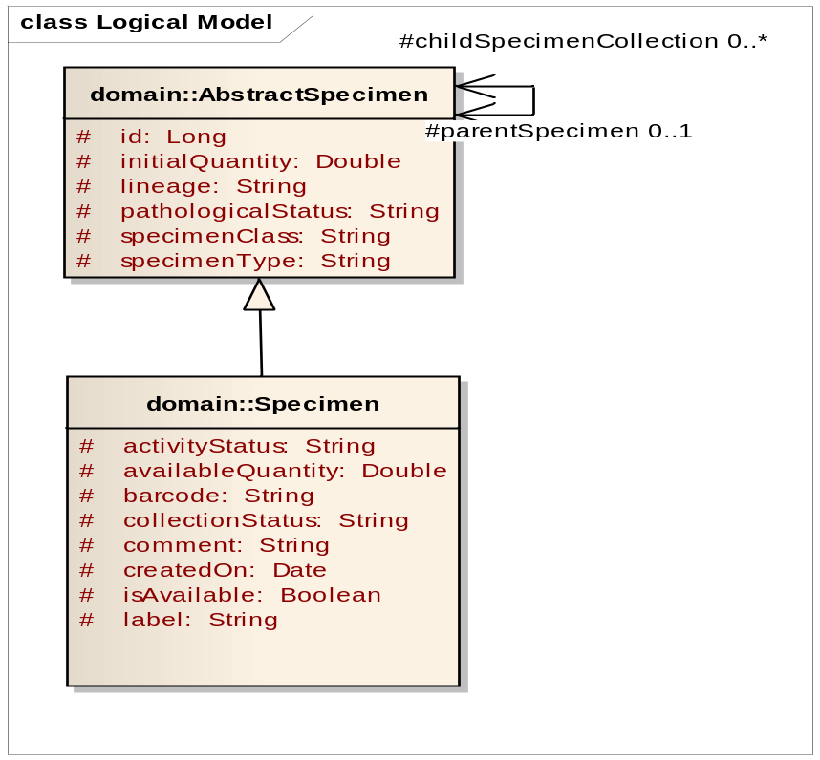
In caTissue, the Specimen is related with other specimens through the parent child relationship. This relationship is captured by the SDRF file.

IDF caTissue Mapping
The system will create a template IDF file that will be filled in manually by the user. As marked below, the system will fill in the details:
IDF | caTissue
Investigation Title | edu.wustl.catissuecore.domain.SpecimenProtocol.title
Experimental Design | N/A
Experimental Design Term Source REF | N/A
Experimental Design Term Accession Number | N/A
Experimental Factor Name | N/A
Experimental Factor Type | N/A
Experimental Factor Term Source REF | N/A
Experimental Factor Term Accession Number | N/A
Person Last Name | edu.wustl.catissuecore.domain.Participant.lastName  edu.wustl.catissuecore.domain.User.lastName
Person First Name | edu.wustl.catissuecore.domain.Participant.firstName  edu.wustl.catissuecore.domain.User.firstName
Person Mid Initials | edu.wustl.catissuecore.domain.Participant.middleName
Person Email | edu.wustl.catissuecore.domain.User.emailAddress
Person Phone | edu.wustl.catissuecore.domain.Address.phoneNumber
Person Fax | edu.wustl.catissuecore.domain.Address.faxNumber
Person Address | edu.wustl.catissuecore.domain.Address.street  edu.wustl.catissuecore.domain.Address.city  edu.wustl.catissuecore.domain.Address.state  edu.wustl.catissuecore.domain.Address.country  edu.wustl.catissuecore.domain.Address.zipCode
Person Affiliation | edu.wustl.catissuecore.domain.Institution.name
Person Roles | Tissue Collection Supervisor  Tissue Collection Technician  Tissue Collection PI  Tissue Collection Scientist  Tissue Collection Coordinator  Tissue Collection Participant
Person Roles Term Source REF | N/A
Quality Control Type | N/A
Quality Control Term Source REF | N/A
Quality Control Term Accession Number | N/A
Replicate Type | N/A
Replicate Term Source REF | N/A
Replicate Term Accession Number | N/A
Normalization Type | N/A
Normalization Term Source REF | N/A
Normalization Term Accession Number | N/A
Date of Experiment | N/A
Public Release Date | N/A
PubMedID | N/A
Publication Author List | N/A
Publication Status | N/A
Experiment Description | N/A
Protocol Name | N/A
Protocol Type | N/A
Protocol Description | N/A
Protocol Parameters | N/A
Protocol Hardware | N/A
Protocol Software | N/A
Protocol Contact | edu.wustl.catissuecore.domain.SpecimenProtocol.principalInvestigator
Protocol Term Source REF | N/A
Protocol Term Accession Number | N/A
SDRF File | Configurable
Term Source Name | Configurable
Term Source File | Configurable
Term Source Version. | Configurable
For each term source used in the SDRF file, a corresponding column will be generated in the IDF.

SDRF caTissue Mapping
For reference, the diagram below shows the overall structure of an SDRF file.

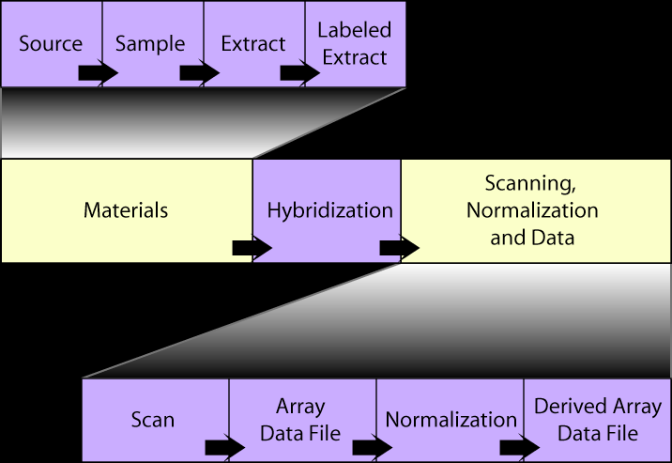
The sections Source, Sample, and Extract will be derived from caTissue. An unfilled Hybridization section will also be generated in the file. The remaining sections are not provided by caTissue.
The Source block in the SDRF file provides the meta-data about a Sample. This will be a top-level specimen.
SDRF | caTissue | Notes
Source Name | edu.wustl.catissuecore.domain.AbstractSpecimen.label
Provider | edu.wustl.catissuecore.domain.Participant
Material Type | edu.wustl.catissuecore.domain.AbstractSpecimen.specimenType | caArray uses MGED ontology for MaterialType
Description | N/A
Characteristics | OrganismPart,  ClinicalDiagnosis, PathologicalStatus, and  ExternalId will be provided by default. | OrganismPart -> Tissue Site  DiseaseState -> ClinicalDiagnosis
Comment | edu.wustl.catissuecore.domain.Specimen.comment

By default, the Sample block in the SDRF file will include biomaterial that the extract is directly derived from.
SDRF | caTissue | Notes
Sample Name | edu.wustl.catissuecore.domain.AbstractSpecimen.label
Material Type | edu.wustl.catissuecore.domain.AbstractSpecimen.specimenType | caArray uses MGED ontology for MaterialType
Description | N/A
Characteristics[] | OrganismPart,  ClinicalDiagnosis, PathologicalStatus, and  ExternalId will be provided by default. | OrganismPart -> Tissue Site  DiseaseState -> ClinicalDiagnosis
Comment[] | edu.wustl.catissuecore.domain.Specimen.comment

By default, the Extract Block in the SDRF file will include a Molecular Specimen extracted from the sample. If the specimen is not a molecular specimen, this block will be left blank.
SDRF | caTissue | Notes
Extract Name | edu.wustl.catissuecore.domain.AbstractSpecimen.label
Material Type | edu.wustl.catissuecore.domain.AbstractSpecimen.specimenType | caArray uses MGED ontology for MaterialType
Description | N/A
Characteristics[] | OrganismPart,  ClinicalDiagnosis, PathologicalStatus, and  ExternalId will be provided by default. | OrganismPart -> Tissue Site  DiseaseState -> ClinicalDiagnosis
Comment[] | edu.wustl.catissuecore.domain.Specimen.comment

The Labeled Extract Name will not be available from caTissue. This block will not be generated.
The Hybridization Section will be filled in with a template, but is expected to be manually edited by the user.
There will be fixed mappings between caTissue values and caArray values. These specifically will be:
caTissue Value (Vocabulary) | caArray Value
(See below) | Material Type MGED Ontology
Tissue Site (NCI Meta CUI, NCI Code) | Organism Part
Clinical Diagnosis (SNOMED) | Disease State
Global Specimen ID | External ID

MGED Material Type to caTissue Mapping
The following table is a mapping from MGED MaterialType values to corresponding values used in caTissue. By default, this mapping will be a part of the caTissue installation.
MGED MaterialType | caTissue Value
DNA | Specimen Class=Molecular, Type=DNA
cell | Specimen Class=Cell, Type=Any
cell_lysate | Specimen Class=Cell, Type=N/A
cytoplasmic_RNA | Specimen Class=Molecular, Type=RNA, cytoplasmic
genomic_DNA | Specimen Class=Molecular, Type=Whole Genome Amplified DNA
molecular_mixture | Specimen Class=Molecular, Type=N/A
nuclear_RNA | Specimen Class=Molecular, Type=RNA, nuclear
organellar_DNA | Specimen Class=Molecular, Type=N/A
organellar_RNA | Specimen Class=Molecular, Type=N/A
organism_part | Specimen Class=Tissue, Type=Any
polyA_RNA | Specimen Class=Molecular, Type=RNA, poly-A enriched
protein | Specimen Class=Molecular, Type=protein
synthetic_DNA | Specimen Class=Molecular, Type=N/A
synthetic_RNA | Specimen Class=Molecular, Type=N/A
total_RNA | Specimen Class=Molecular, Type=N/A
virus | N/A
whole_organism | N/A

Implementation
The implementation uses the LIMPOPO version 1.0 open source MAGE-TAB parser (http://limpopo.sourceforge.net/) to create MAGE-TAB formatted files. The LIMPOPO MAGE-TAB Parser is a Java library for MAGE-TAB parsing, validating, and programmatic object modeling. It becomes an object model that represents the IDF format as listing of key/value pairs and SDRF as a comprehensive graph.
The implementation uses the Dozer version 5.3.1 open source Java Bean to Java Bean mapping library (http://dozer.sourceforge.net/). Dozer can recursively copy data from one object to another. Dozer also supports simple property mapping, complex type mapping, bi-directional mapping, implicit-explicit mapping, and recursive mapping.
Mappings from caTissue to MAGE-TAB are all expressed in Dozer. This allows caTissue installation to modify the mapping using configuration. In other words, the mappings may be modified on a per installation basis.
The functionality will be accessed through the caTissue web user interface that is implemented using Struts. The implementation employs AJAX techniques to provide ease of use for the user.
The diagram below shows the various modular layers the support this functionality.
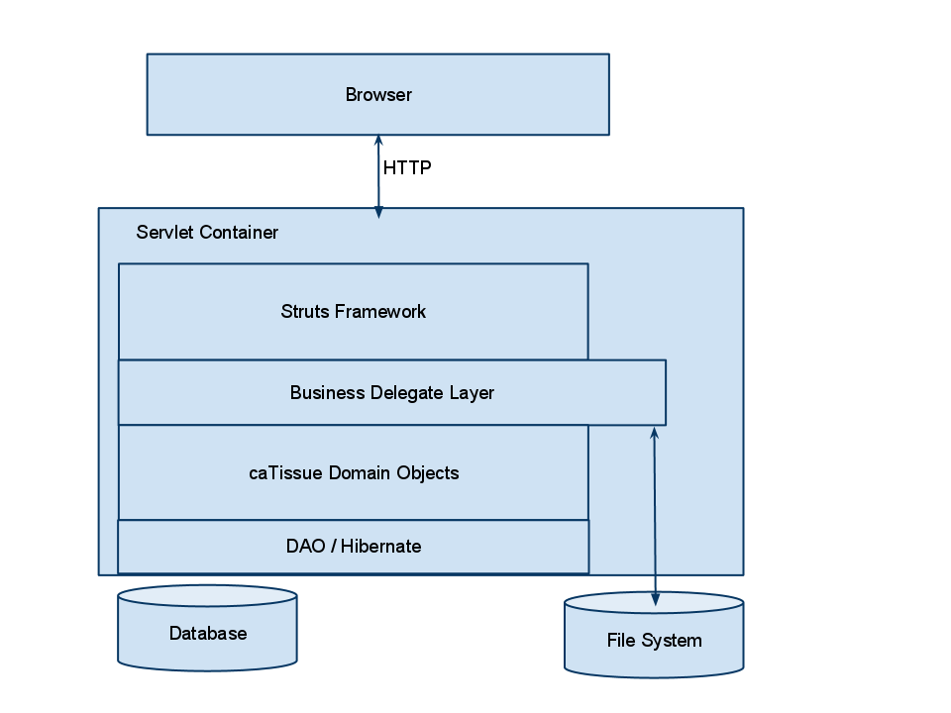
The export is accessed through a web browser that is invoked via HTTP, a servlet container (i.e. JBoss). The Struts framework is used to handle the invocation. A Business Delegate specifically created to support this functionality performs the export operation, reading caTissue domain objects and storing the MAGE-TAB files into the file system. Upon completion, the files are zipped and transferred back in the HTTP response.
Security of the system is handled by the mechanisms supported by the caTissue applications.

System Flow
The following activity diagram shows the flow of the implementation through the system.
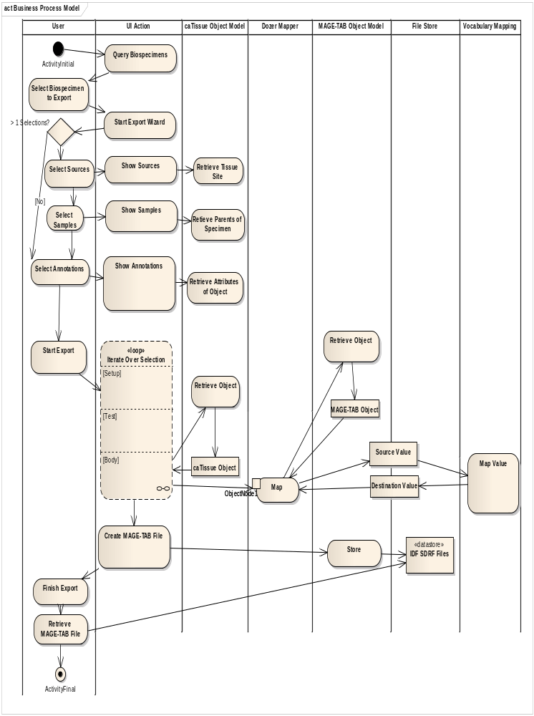
The user selects specimens from the results of a query. The MAGE-TAB export action is initiated by the user. The MAGE-TAB export action is available only if the selected specimens are molecular specimens.
If the user selects a single specimen, then the user selects a specific parent specimen from the parent specimens of the exported specimen to serve as the source and sample specimen.
The user then selects the annotations that are to be exported. The annotations are the set of attributes of the specimen and each of the selected parent specimens selected in the previous steps.
The user then starts the export process. The process iterates over all of the specimens. The iteration loop sends each specimen to a configured Dozer mapper. The Dozer mapper creates a corresponding MAGE-TAB object and for each attribute value in the caTissue specimen, maps it to a corresponding attribute in the MAGE-TAB model. The iteration stops when all specimens and its parents in the selection have been processed.
Upon completion of the loop, the MAGE-TAB files are exported into the IDF and SDRF formats. These files are stored in an internal file store that is subsequently retrieved by the user in a single zip file.

References
MAGE-TAB - Specification 1.0:
http://www.mged.org/mage-tab/spec1.0.html
Investigative Design Format (IDF):
http://tab2mage.sourceforge.net/docs/idf.html
Sample and Data Relationship Format (SDRF):
http://tab2mage.sourceforge.net/docs/sdrf.html
LIMPOPO MAGE-TAB Parser:
http://limpopo.sourceforge.net/
Dozer Java Bean to Java Bean Mapper:
http://dozer.sourceforge.net/

